Arabesque Caning and Floral Eruption Pendant Workshop
Jana Roberts Benzon

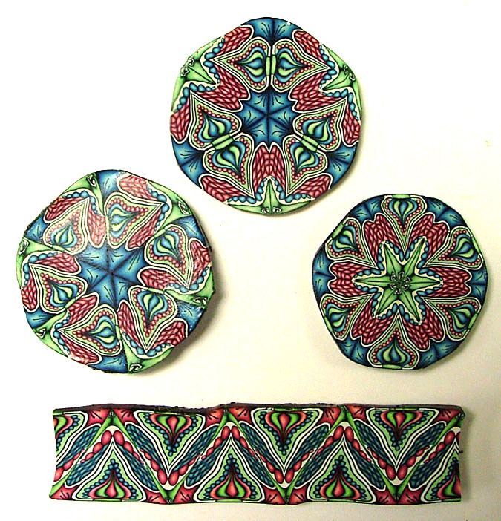
This two day workshop begins with learning to build an intricate, colorful Arabesque Cane (shown in picture, left….yes, you WILL create these exact canes!). The term “Arabesque Canes” is one I’ve coined to describe canes that go beyond kaleidoscoping…when the finished cane is cut and combined, intricate lines link up to give continuity and a harmonious, beautiful design throughout the cane. After constructing the cane, you will learn the unique way I prepare a cane for reduction, and then the “like magic” cane reduction method itself…it’s an efficient and innovative way to reduce canes, focusing on minimal distortion and waste (one of those techniques that students say is “worth the price of admission” alone!). After reduction, learn to cut and combine your Arabesque Cane into four different cane configurations.
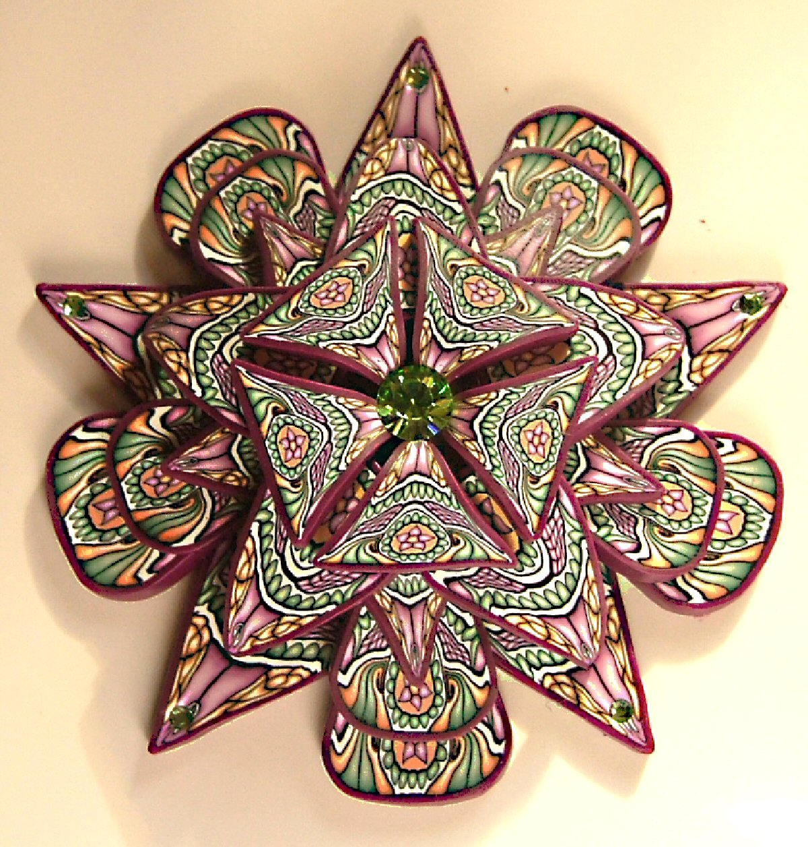

The second segment of this workshop is learning to create a “Floral Eruption” Pendant using your Arabesque cane. This pendant’s (photo left) beautiful design gives the impression of flower petals opening up, erupting from the flower center, very chrysanthemum-like…..a design that you will find so many uses for in creating earrings, pendants, brooches and more.

This workshop is completely full of new, innovative and “thinking outside of the box” caning, reduction and general claying tips and skills. This workshop is an ‘over the top’ event in which students come away brimming with new knowledge and excitement about the endless possibilities of polymer clay. By the end, you’ll be exhausted in that wonderful way that only comes from having worked and learned and played harder than you’d imagine you could!!

Testimonials
"I want to thank you so very much for sharing yourself and your amazing expertise. You are an amazing artist with the rare ability to share your knowledge with others. As you said to me in our class, I have had the good fortune to learn from several incredibly talented artists and teachers but you are certainly one of the best. The hours and hours of time required to develop your skills and expertise is extremely impressive. I recognize after spending 2 days with you that your incredible creativity allows you to come up with techniques no one else has thought of. Then the hours of work you put into preparing for the class is very evident. Finally, you explain things so clearly and in such detail that I understood immediately what I needed to do to produce a beautiful polymer cane. But more than anything else, your sincerity and openness allowed me to truly enjoy you and therefore my entire weekend. Every time I look at my cane I can't stop myself from smiling. That feeling of happiness is priceless."-Barbara Johnson in Lenexa, Kansas

“Dear Jana, your wonderful arabesque caning class is now 3 days passed and I am still in awe of what I learned. I woke up in the middle of the night on Sunday just to check on my ....cane!! It is so beautiful. I want to tell you what I learned from class. 1) Trust~ every step of the way you repeated those words to us "trust me"~ you were right on and what a lesson that is. 2) Faith~in my own abilities and in my ability to learn a new way of claying. 3) Patience- one of the things I have always liked about clay was it's immediacy in delivering pleasing outcomes. You made us WAIT- and it was worth it. These are the 'extra' things I learned. You are a wonderfully grounded and 'in touch' instructor. You had your eye on every student and your ear on every conversation even tho there were 15 of us! I am wondering now what to do with all I learned from you. I know I will never look at clay the same way again~ thanks so much and I hope you will return next year. “
Cynde Tagg in Albuquerque, New Mexico

I had the privilege of attending Jana's Arabesque Caning workshop in Albuquerque in October 07. If you have never attended one of her workshops, don't delay and sign up for one today! Jana is an accomplished teacher and unselfishly shares her knowledge about all things polymer. She was so patient and encouraging to all of us in the class, and even the beginner students produced wonderfully beautiful canes. The experience was truly amazing. Her handouts are detailed and her "Tips and Tricks" were worth the price of admission. We all felt that Jana took us to the next level in our ability as polymer clay artists. Thanks, Jana!!
Annie Hooten in Albuquerque, New Mexico

