New Age Bargello Workshop
Jana Roberts Benzon
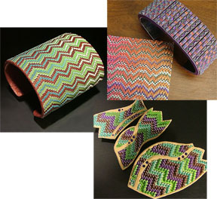

From the moment I first began creating this new, updated version of Bargello, I’ve looked forward to the day when I’d be able to teach it – how excited I am that I am now offering this as one of my Master Workshops and have the opportunity to share this ‘out of the box’ technique! These new pieces have been referred to as (looking like) beadwork, woven textile, leather and even ceramic…regardless, it can be turned into any finished art project you can conjure! In our workshop, we’ll create a brooch pin or pendant and earrings. We will begin by creating a multi-process, dimensional ‘sheet’ (during which you’ll no doubt have many ah-ha moments and learn some really great, new ‘tricks’!); next, we’ll turn that sheet into patterned Bargello – you’ll have the opportunity to choose which pattern you’d like to create (or come up with one of your own!). We’ll then create the finished brooch or pendant, with instruction that includes loads of information about mechanically (and artfully!) bonding adornments, pin backs and bails to your creations and also how to put a lovely back on your piece. Our two days together will include plenty of “play” and exploring time, and with this magical technique, you’ll be able to get lost in the wonder of creating!
Feel free to contact me with any questions (jana@janarobertsbenzon.com); additionally, you can see more examples of my work at my website: www.janarobertsbenzon.com …thanks for your interest!

