“Organics” Workshop Description
Jana Roberts Benzon
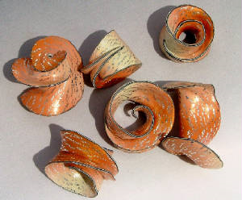
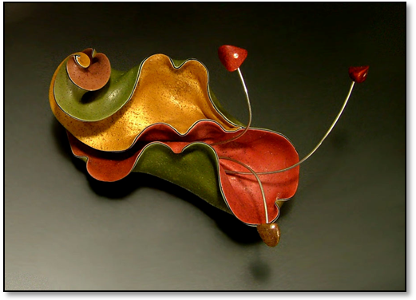

Join Jana for two days spent ‘going with the flow’ as we learn to create ethereal, magical “Organic Sculpture” pieces, with their delicate black ‘outlining’ – this eye-catching, mesmerizing feature helps give these creations their distinguishing look. This workshop has a wonderful mix of technical instruction and ‘free-form’ time; we’ll learn how to create glittering Sea Shell beads, incorporating many of the basic skills for creating Organics with a beautiful, sparkling exterior. We’ll also learn to create a Sea Sculpture Brooch with its rough, crustacean-like exterior, and then the Seahorse Pendant with the beautiful (and mystifying!) “Netting” technique that adorns its outer shell. If time, we’ll also learn how to make a “Crumpled Brooch”, one of Jana’s favorites. You’ll learn the basics of Organics, several interesting shapes and designs, along with several new surface techniques in this workshop…
This Master Workshop is full of free-form fun, relaxed “in the zone” creating time, and also filled with so much new and innovative polymer information – you’ll leave feeling like your head is going to explode – in a good (organic) way!!
See more Organics examples at Jana’s website: www.janarobertsbenzon.com
